MooseFS Build and Install and Test

## Description

Our team, consisting of Quentin Degiorgio, Drew Bikowicz, Noah Beckman, and Sarah Fornaldes, researched, deployed, and tested a MooseFS file share system. Our objective is to deploy the MooseFS file share system on a networked environment, where clients can share files between themselves using a mounted drive.The build consists of two Centos Chunkservers, a CentOS Master server, a CentOS metalogger server, three Ubuntu Server clients, and a client machine with running a web browser.

[GitHub Link](https://github.com/CyPH3RSkULL5/Network-Storage-Project)  
[Presentation Link](https://docs.google.com/presentation/d/1_omv6Vt4_iqgkL7S-Wy-i_FeUThsXo5ztesCe1tzjfs/edit#slide=id.gcaa31e981c_4_11)

## References

* <https://moosefs.com/Content/Downloads/moosefs-installation.pdf>
* <https://burnhamforensics.com/2019/04/06/moosefs-build-and-installation-guide/>
* <https://moosefs.com/Content/Downloads/moosefs-3-0-users-manual.pdf>

## Build The following

* Create four Centos 7 infrastructure servers on the LAN, you will need your router
* chunk01 and chunk02 will be infrastructure servers, each with a second drive. Make sure the second drive is unconfigured during installation. We will do that manually with parted later.
* Create three Ubuntu Server 20.04 infrastructure servers on the LAN. One of the client machines (client01) will need Apache2 installed.
* A client machine with access to a web browser.

|  |
| --- |
| 💡 MooseFS does not require DNS, it can use IP addresses, but if DNS is configured on the network, hostnames will also work in configuration files. |

## Networking

* mgmt01: 10.0.5.10/24
* master: 10.0.5.20/24
* metalogger: 10.0.5.21/24
* chunk01: 10.0.5.22/24
* chunk02: 10.0.5.23/24
* client01: 10.0.5.30/24
* client02: 10.0.5.31/24
* client03: 10.0.5.32/24

Set the default gateway to your gateway address (10.0.5.2) and DNS to either your DNS server (10.0.5.10), or external DNS (8.8.8.8).

### Network Diagram:

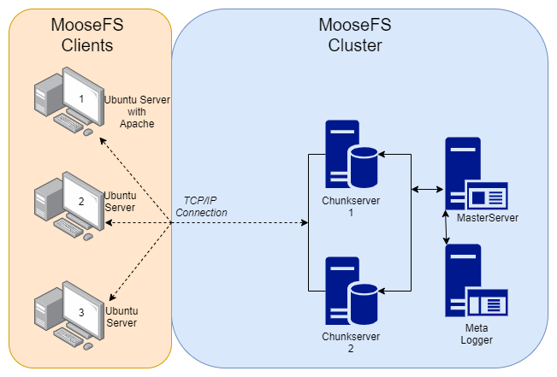

## Configure MooseFS Master Server

### Configure MooseFS Repository

curl "https://ppa.moosefs.com/RPM-GPG-KEY-MooseFS" > /etc/pki/rpm-gpg/RPM-GPG-KEY-MooseFS

curl "http://ppa.moosefs.com/MooseFS-3-el7.repo" > /etc/yum.repos.d/MooseFS.repo

### Install MooseFS Master Server and Web GUI

yum install moosefs-master moosefs-cgi moosefs-cgiserv moosefs-cli

### Start MooseFS Master Server and Web GUI services

systemctl enable moosefs-master  
systemctl start moosefs-master

systemctl enable moosefs-cgiserv  
systemctl start moosefs-cgiserv

### Add Firewall Rules for MooseFS services

firewall-cmd --zone=public --add-service=http --permanent  
firewall-cmd --zone=public --add-port=9425/tcp --permanent  
firewall-cmd --zone=public --add-port=9419/tcp --permanent  
firewall-cmd --zone=public --add-port=9420/tcp --permanent  
firewall-cmd --zone=public --add-port=9421/tcp --permanent

firewall-cmd --reload

### Access Web GUI

In your web browser, access the Web GUI via <hostname/IP of Master Server>:9425.

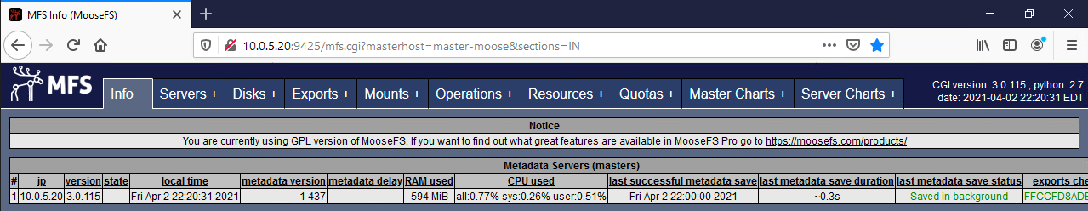

## Configure MooseFS Metalogger

### Configure MooseFS Repository

curl "https://ppa.moosefs.com/RPM-GPG-KEY-MooseFS" > /etc/pki/rpm-gpg/RPM-GPG-KEY-MooseFS

curl "http://ppa.moosefs.com/MooseFS-3-el7.repo" > /etc/yum.repos.d/MooseFS.repo

### Install MooseFS Metalogger

yum install moosefs-metalogger

### Point Metalogger to Master Server

cd /etc/mfs  
nano mfsmetalogger.cfg

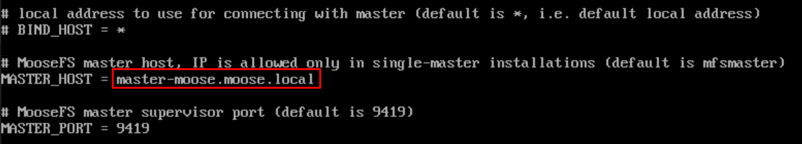

### Start MooseFS Metalogger service

systemctl enable moosefs-metalogger  
systemctl start moosefs-metalogger

### Add Firewall Rules for MooseFS services

firewall-cmd --zone=public --add-port=9422/tcp --permanent

firewall-cmd --reload

## Configure MooseFS Chunkservers

|  |
| --- |
| 💡 Follow these configuration steps for each chunkserver in your environment. |

### Configure MooseFS Repository

curl "https://ppa.moosefs.com/RPM-GPG-KEY-MooseFS" > /etc/pki/rpm-gpg/RPM-GPG-KEY-MooseFS

curl "http://ppa.moosefs.com/MooseFS-3-el7.repo" > /etc/yum.repos.d/MooseFS.repo

### Install MooseFS Chunkserver

yum install moosefs-chunkserver

### Point Chunkserver to Master Server

cd /etc/mfs  
nano mfschunkserver.cfg

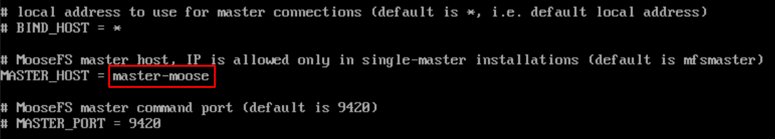

### Create and Format Partition on the Second Drive

parted -l  
parted --align optimal /dev/scb

(parted) mklabel gpt  
(parted) mkpart mfschunks1 0% 100%  
(parted) q

Install Dependency:

yum install xfsprogsls

mkfs.xfs /dev/sdb1

Add the following to /etc/fstab:

/dev/sdb1/ /mnt/mfschunks1 xfs defaults 0 0

Create the mount directory and mount the new partition:

mkdir /mnt/mfschunks1  
mount /mnt/mfschunks1

Change ownership so MooseFS can make changes:

chown mfs:mfs /mnt/mfschunks1  
chmod 770 /mnt/mfschunks1

Append the following to /etc/mfs/mfshdd.cfg:

/mnt/mfs

### Start MooseFS Chunkserver service

systemctl enable moosefs-chunkserver  
systemctl start moosefs-chunkserver

## Configure Clients

|  |
| --- |
| 💡 Follow these configuration steps for each client in your environment. |

### Configure MooseFS Repository

curl "https://ppa.moosefs.com/RPM-GPG-KEY-MooseFS" > /etc/pki/rpm-gpg/RPM-GPG-KEY-MooseFS

curl "http://ppa.moosefs.com/MooseFS-3-el7.repo" > /etc/yum.repos.d/MooseFS.repo

### Install MooseFS Client and Dependencies

apt install fuse fuse-devel  
apt install moosefs-client

### Mount MooseFS Filesystem

For normal clients, use the following command to create and mount /root/moose:

mkdir -p /root/moose  
mfsmount /root/moose -H <hostname/IP of master server>

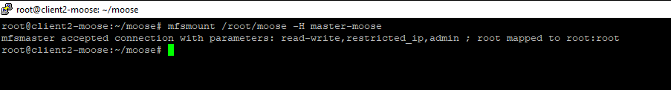

For the Apache2 client (client01), use the following command to mount /var/www/html/moose:

mfsmount /var/www/html/moose -H <hostname/IP of master server>

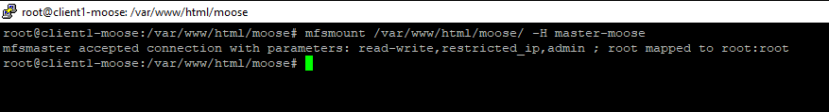

The clients should now be visible in the MooseFS dashboard:

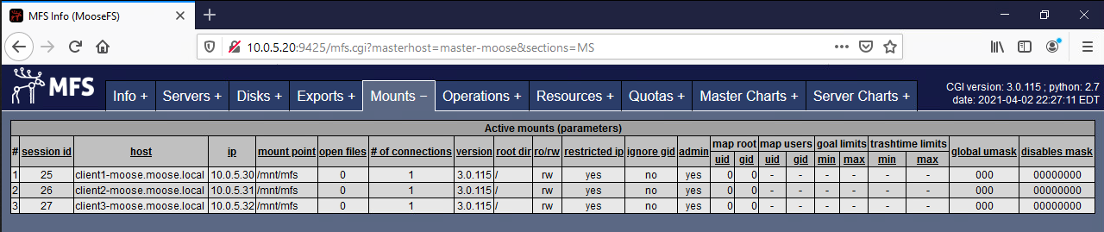

## Test Script

1. Write a file to client01:/var/www/html/moose
2. Show that it arrives on client02 and client03 and can be navigated to via browser
3. Bring down client03
4. Write another file to client01
5. Show that it arrives in client02 and that it shows up in apache
6. Bring up client03 and demonstrate that the file on client02 replicates over to client03

## Test Video

[Demonstration Video Link](https://drive.google.com/file/d/1ppS6-75omMdPn0YvV-ktfcco8j73n7Dp/view?usp=sharing)